The Facts on Vaccination
Vaccines are a miracle of medical technology, allowing humanity to combat diseases that would otherwise be devastating. New COVID-19 vaccines are especially valuable, offering a chance to end the COVID-19 pandemic. These vaccines are the product of tireless work from scientists and researchers. Yet, with the recent vaccine breakthroughs, there is also backlash. According to a poll from Pew Research Center, 39% of people say they will not be receiving the vaccine (2). An unfounded undercurrent of fear regarding COVID-19 vaccines has emerged, and it is important to be informed on the facts of COVID-19 vaccines’ importance.
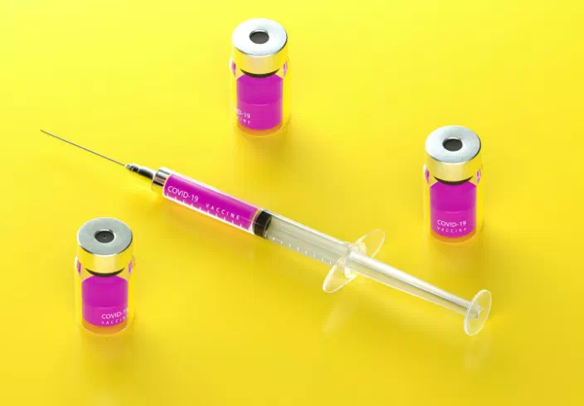
How do mRNA vaccines work – and why do you need a second dose? 5 essential reads (yahoo.com)
The first misconception to address is the idea that the COVID-19 vaccines are untested. While it is true that COVID-19 vaccines are being rolled out faster than usual, they have also undergone intense scrutiny to make sure they meet safety standards. This includes a four-stage approval process from the FDA, an approval from the EUA, and an approval from the CDC (1). Currently, the CDC is monitoring for any potentially serious risks and side effects, but none have been found thus far (1). Many have already received the vaccine, such as those in emergency and medical fields.
The way that the Pfizer and Moderna vaccines work is via a unique technique. They send mRNA into the body, which tells the cells to produce some of the proteins produced by the COVID-19 virus. The immune system recognizes these proteins as foreign and develops an immune response to them (2). Essentially, this means that only a small portion of the COVID-19 virus’ DNA needed to be used in vaccines, rather than the entire pathogen. However, this also means that the vaccine has to be given in two doses. The first dose primes the body’s immune system, and the second dose is what grants true immunity (3). New data collection processes were used, and world governments collaborated, for the expedient development of these vaccines (1).
While the vaccines are safe to use, there are some minor side effects that are to be made known. 70% of those who have taken the vaccine report pain in their arm, according to a survey of 2 million people from the CDC (1). Less than a third of people also have reports of tiredness, headaches, and nausea (1). These symptoms are minor, but noteworthy all the same. The larger difficulty facing the COVID-19 vaccines has to do with means of delivery. They must be stored in subzero temperatures, to prevent spoiling of the mRNA material (3). Thus, there is a vast supply chain being developed, to properly preserve the vaccines.
COVID-19 is an advent in history that will never be forgotten. How we choose to move forward will forever set the precedent for how pandemics like this will be handled in the future. While the idea of getting a shot is never comfortable, in times like these we need to put aside what is comfortable and trust in the broader scientific process.
Sources:
- Is the COVID-19 Vaccine Safe? | Johns Hopkins Medicine
- The Covid vaccine is safe, whatever anti-vaxxers say. Here's why we can trust it. (nbcnews.com)
- How do mRNA vaccines work – and why do you need a second dose? 5 essential reads (yahoo.com)

